Quality
X=$\frac{hi-hf1}{hgi-hfi}$, you can use specific volume, internal energy, and specific mass
Information:
SISO, PE applies(g(z)), KE applies(V^2), Q applies, W applies, steady state
$$0=\dot{Q}-\dot{W}+\dot{m}\left(\left(h1-h2\right)+\frac{V^{2}1-V^{2}2}{2}+g\left(z1-z2\right)\right)$$
$$\dot{Q}-\dot{W}=-\dot{m}\left(\left(h1-h2\right)+\frac{V^{2}1-V^{2}2}{2}+g\left(z1-z2\right)\right)$$
$$\dot{Q}-\dot{W}=\dot{m}\left(\left(h2-h1\right)+\frac{V^{2}2-V^{2}1}{2}+g\left(z2-z1\right)\right)$$

$$P*v=R*T→v=\frac{RT}{P}$$
$$Δh=Cp(T2-T1)$$
$$Cp=\frac{k*R}{k-1}$$
$$R=\frac{\overline{R}}{M}$$
$$Cp*T1=h1; Cp=\frac{Δh}{ΔT}$$
$$h_{1}=h_{f}\left(T_{1}\right)+v_{f}\left(T_{1}\right)*\left[P_{1}-P_{sat}\left(T_{1}\right)\right]$$
$$\overline{R}=R*Molecular Mass$$
$$\dot{m}=density*Velocity*Area =\frac{V*A}{v}=ρVA=\frac{P*A*V}{R*T}$$
$$Q=V*A$$
$$\dot{m}=\frac{Q}{V}$$
$$\dot{W}=\frac{w}{T}=Power=\frac{kJ}{s} also \dot{Q}=\frac{kJ}{s}$$

AV is volumetric flow rate
convert $\frac{m^{2}}{s^{2}}to\frac{kJ}{kg}, multiply by\frac{1}{1000}$
convert $\frac{ft^{2}}{s^{2}}$to $\frac{Btu}{lbf}, multiply by\frac{1}{32.174}*\frac{1}{778.17}$
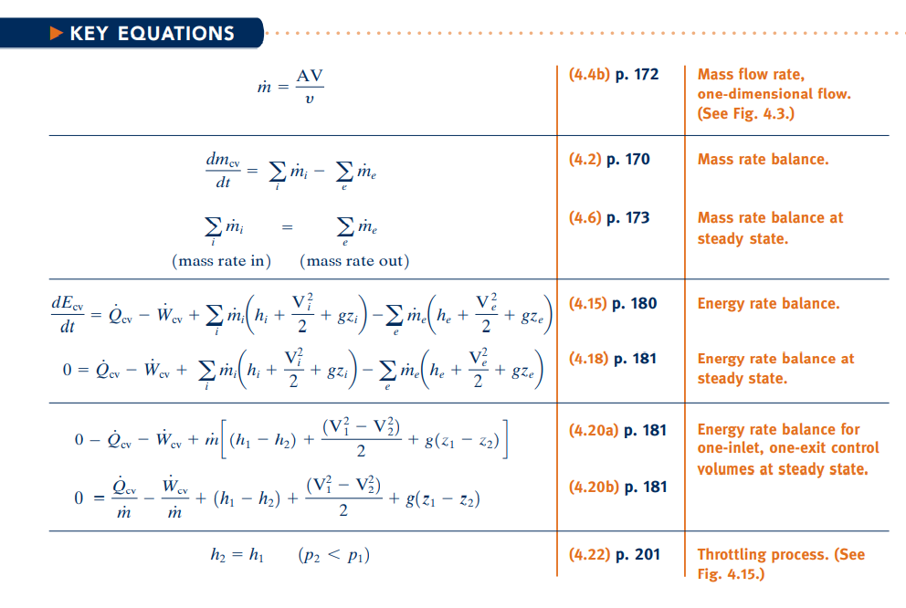

English Units:
$$\dot{m}={lb}/s;A=ft^{2};v={ft^{3}}/{lb};V=\frac{ft}{s}, P=psf;h=Btu/lbm$$
SI Units:
$$\dot{m}={kg}/s;A=m^{2};v={m^{3}}/{kg};V=m/s , AV={m^{3}}/s;P=kPa$$

100KPa= 1 bar
Superheated vapor table:
STEAM: (need pressure(MPa, bar), temp(C°) )
Saturated vapor(steam): need pressure, just use saturated row.

INFO 11-08-2021
$$\dot{m}=density*Velocity*Area =\frac{V*A}{v}=ρVA$$
$$Q=V*A$$
$$\dot{m}=\frac{Q}{V}$$
$$\dot{W}=\frac{w}{T}=Power=\frac{kJ}{s} also \dot{Q}=\frac{kJ}{s}$$
$$ΔE=0$$
Turbines
Will have x(quality)
$$h_{2}=h_{f}-x\left(h_{g}-h_{f}\right)$$
Compressor
Will use Ideal Gas $Pressure*specific volume=R*Temperature$
$$\overline{R}=R*Molecular Mass$$
Pump
Generally, There is: Δz(height) & ΔPressure
$$h_{1}=h_{f}\left(T_{1}\right)+v_{f}\left(T_{1}\right)*\left[P_{1}-P_{sat}\left(T_{1}\right)\right]$$

CHAPTER 5
$$Q_{H} Q_{R} Q_{L} W_{in}$$
Closed system→u
$$cv→h=u+ρ*υ$$
Energy transfer from a system with higher entropy to a system with lower entropy.
Entropy: amount of disorder in a system.
Entropy equals “S”
entropy of gas > entropy of a liquid.
$$η_{max}=\frac{W_{net}}{Q_{H}}=\frac{Q_{H}-Q_{L}}{Q_{H}}$$
$$Thus, W_{net}=Q_{H}-Q_{L}$$
$$Δs=\frac{ΔQ}{T}$$
$$ΔS=m_{L}\left(s_{F}-s_{L}\right)+m_{R}(s_{F}-s_{R})$$
$$Where s_{F}=s\left(T_{F}\right), etc.$$
$$ΔS=\left[m_{L}\left(s_{F}-s_{L}-R*\ln\left(\frac{P_{F}}{P_{L}}\right)\right)\right] +\left[m_{R}\left(s_{F}-s_{R}-R*\ln\left(\frac{P_{F}}{P_{R}}\right)\right)\right]$$

$$β_{max}=\frac{Q_{L}}{W_{in}}=\frac{Q_{L}}{Q_{H}-Q_{L}}=\frac{Q_{L}}{Q_{H}}-1 refrigeration$$
$$γ_{max}=\frac{Q_{H}}{W_{in}} heat pump$$
Irreversible- System and surrounding can’t return to their initial state/condition
Δs>0 or s2>s1 →Irreversible

$$σ+\frac{Q}{T}=S_{2}-S_{1}$$

